**CREATE INSTANCE USING TERRAFORM**

**Step 1:** Create an instance and copy the ami id and remember the name of .pem file.

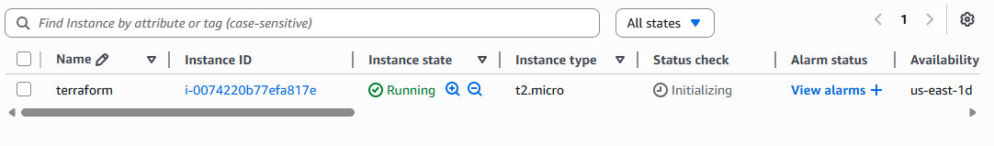

Step 2: Connect the instance and run the following commands to install Terraform:

**Commands:**

**$ sudo apt update**

**$ sudo apt install docker.io -y**

**$ sudo usermod -aG docker ubuntu (** reconnect the instance to see the changes **)**

**$ docker pull hashicorp/terraform(**this will create the image**)**

Step 3 : Create IAM user and copy the access key , secret key, and paste them in the main.tf file.

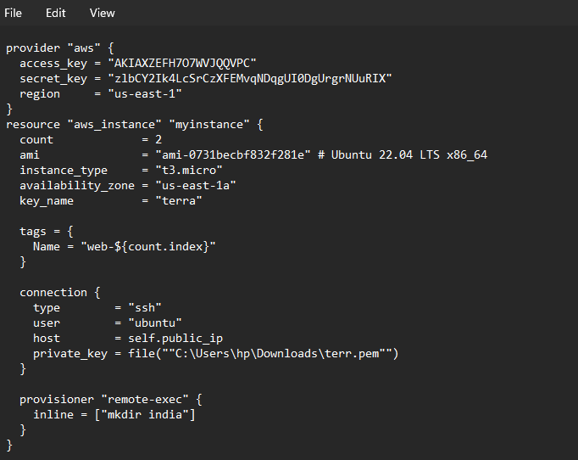



Step 4 : Create a container for the image using the command:

**$ docker run -it -- entrypoint sh -v “$(pwd)”: /workspace -w /workspace hashicorp/terraform**

This command will create a container and it will take us to the container shell

Step 5 : Inside the shell write the following commands and your instance will be created.

**/workspace # terraform init**

**/workspace # terraform plan**

**/workspace # terraform apply**